**Project Design Phase-II**

**Journey Maps**

|  |  |  |  |
| --- | --- | --- | --- |
| Date | 03 November 2022 | | |
| Team ID |  | PNT2022TMID41106 |  |
| Project Name | Analytics For Hospitals' Health-Care  Data | | |

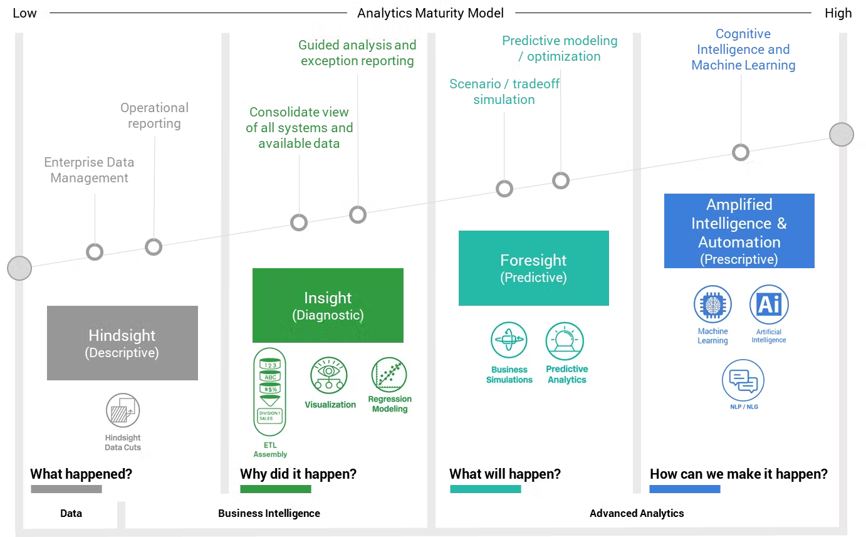

**User Journey Maps**

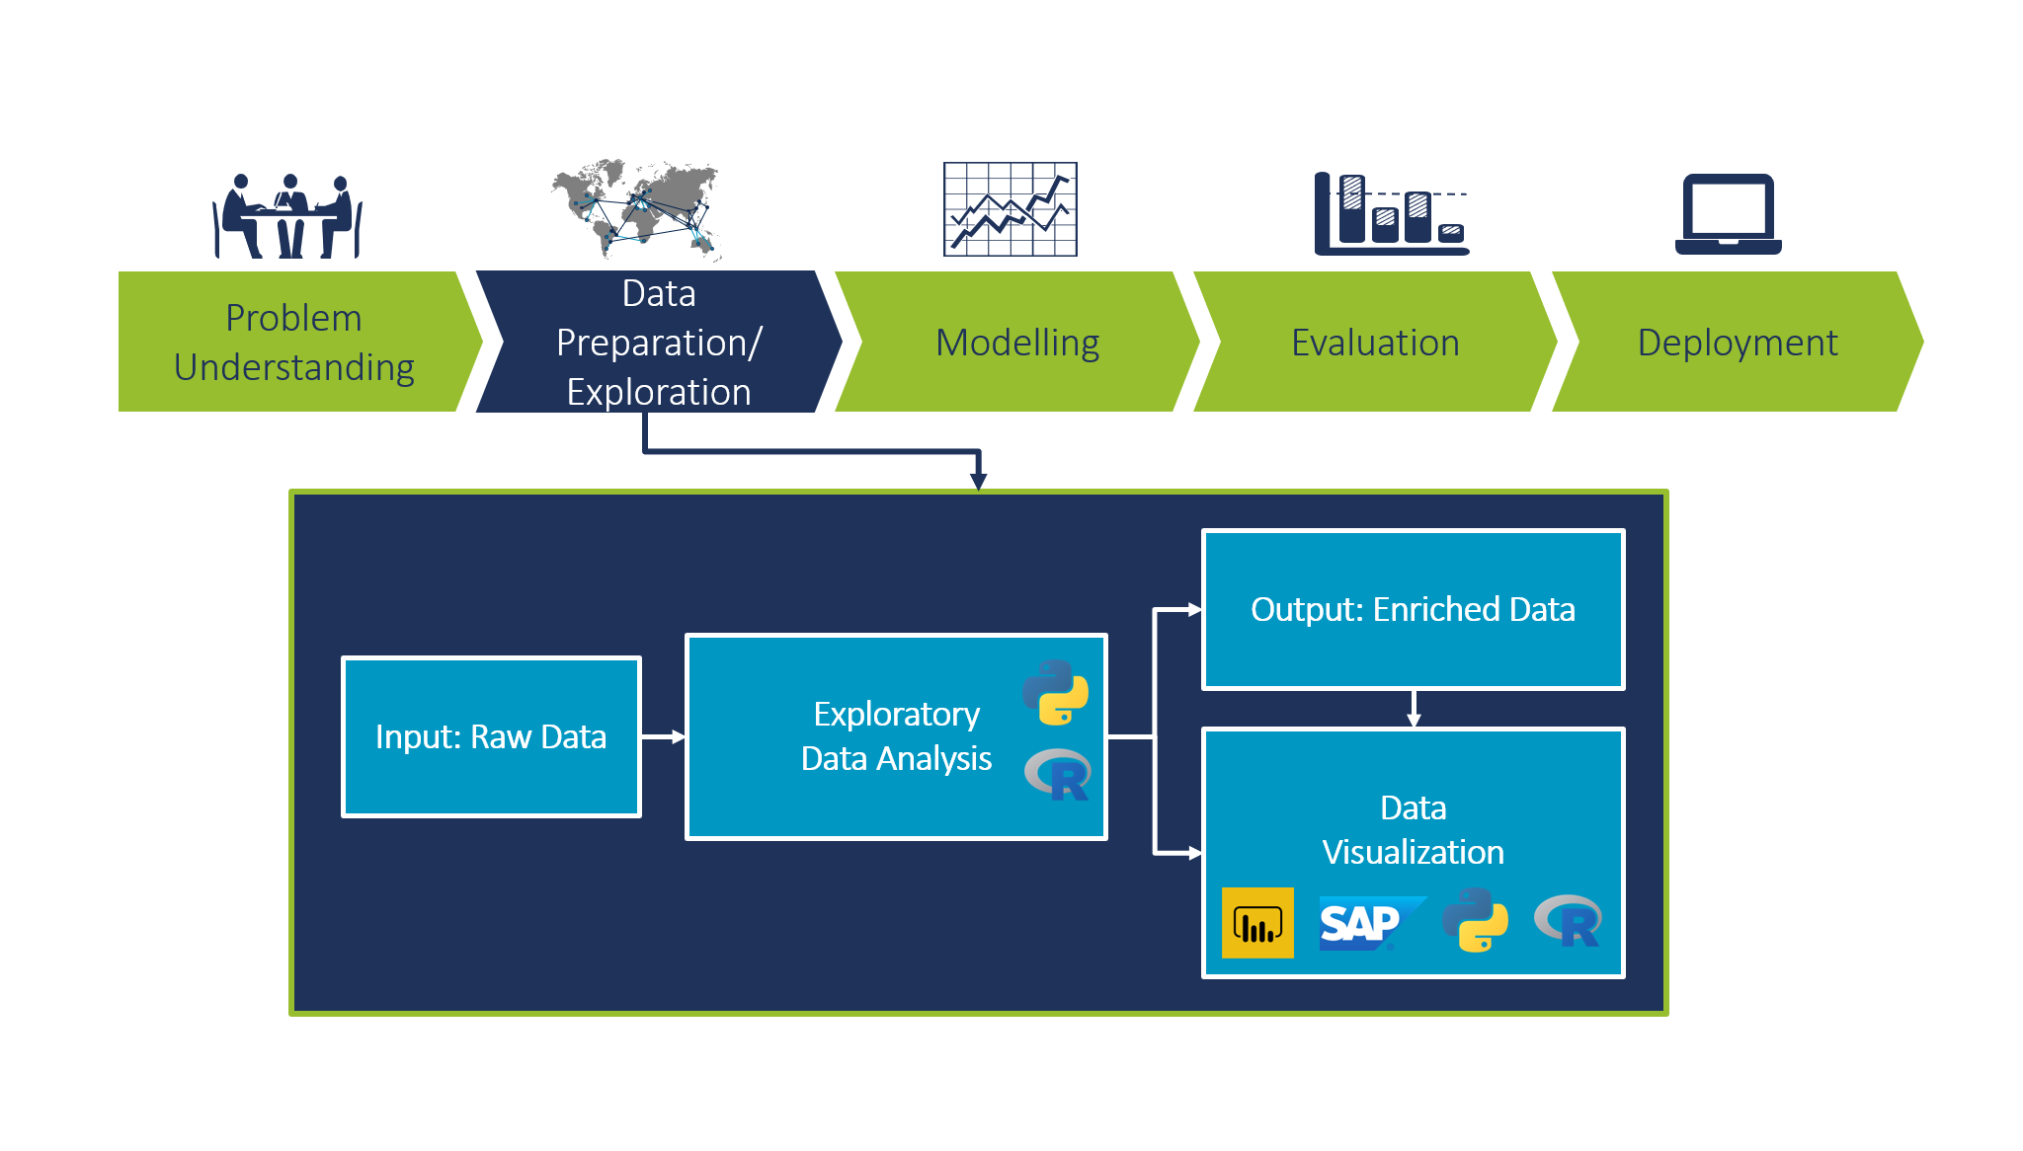

**Data Flow Daigram**